

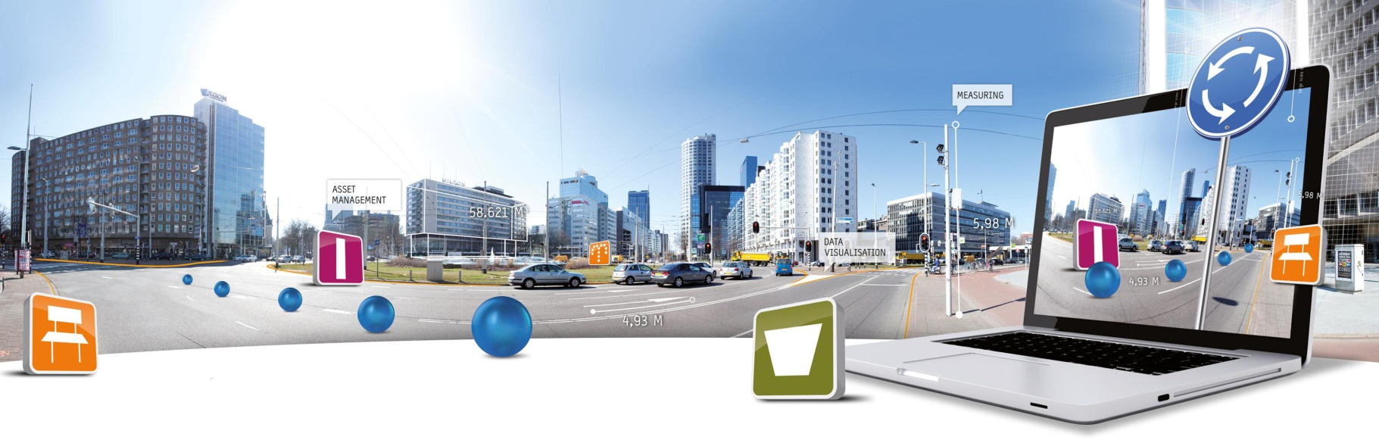

**GlobeSpotter for ArcGIS Desktop User Manual**

Date: 20 February 2015

CycloMedia Technology B.V. | **T** +31 (418) 556100 | **E**: info@cyclomedia.com

# Index

Index 2

1. Installation 3

2. How to use GlobeSpotter for ArcGIS Desktop 9

2.1 Exploring and viewing Cycloramas in ArcMap 9

*2.1.1* *How to show recent recording locations of Cycloramas* 9

*2.1.2* *How to show historical recording locations of Cycloramas* 9

*2.1.3* *How to configure the Cyclorama viewers* 10

*2.1.3* *How to open Cycloramas* 11

2.2 How to show vector data in Cycloramas 12

2.3 Performing measurements 14

*2.3.1* *Standard measurement – point measurement* 14

*2.3.2* *Standard measurement – line / surface measurement* 16

*2.3.3* *Smart Click measurement – point measurement* 18

*2.3.4* *Smart Click measurement – line / surface measurement* 20

*2.3.5* *How to import a measurement in a Cyclorama* 21

*2.3.6* *Undo a measurement* 23

2.4 Cyclorama search functionality 24

# 1. Installation

To install GlobeSpotter for ArcGIS Desktop, please perform the following steps:

1. Check if Adobe Flash Player is installed on your computer. If you do not already have it, please download and install it first via <http://get.adobe.com/flashplayer/>.
2. GlobeSpotter for ArcGIS Desktop can be installed from a disk or network location:
   1. Copy the Add-In file to a (local) disk or network location.
   2. Start ArcMap.
   3. Select menu: *Customize* ► *Add-In Manager* and select the *Options* tab.

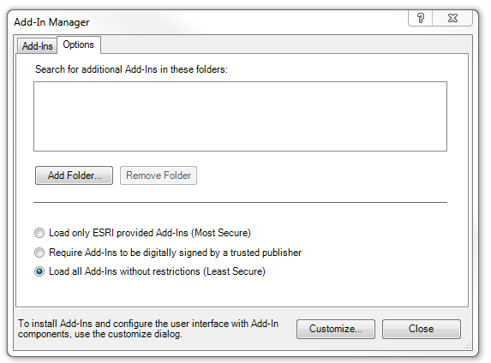

*Add-In Manager*, *Options* tab.

* 1. Click <*Add Folder...*>. Browse to the folder were the Add-In file is located and click <*OK*>.  
       
      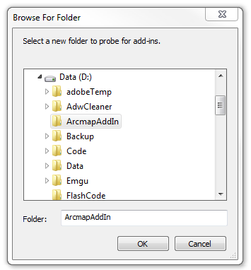

Browse to the folder where the Add-In file is located.

* 1. Close the Add-In Manager and restart ArcMap.
  2. Select menu: *Customize* ► *Add-In Manager*.
  3. Check whether GlobeSpotter for ArcGIS Desktop is ‘*Authenticated’*. If the Add-In is ‘*Untrusted’*, close the Add-In Manager, close ArcMap and install the certificate ‘thawte-intermediate-ca.cer’ first (which is made available together with this user manual).

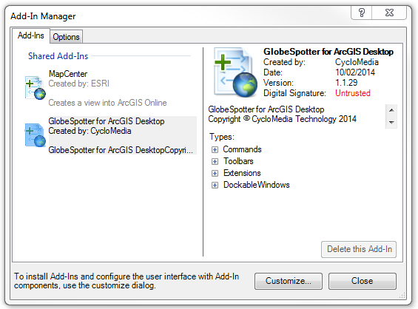

*Add-In Manager*, *Add-Ins* tab, check if GlobeSpotter for ArcGIS Desktop is ‘*Authenticated’* or ‘*Untrusted’*.

* 1. To install the certificate, please perform the following steps:
     1. Double-click on ‘thawte-intermediate-ca.cer’ to install the certificate.  
          
         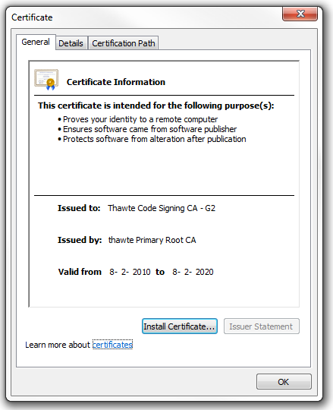

Install the certificate.

* + 1. Click on <*Install Certificate...*> to start the installation wizard for the certificate.   
         
       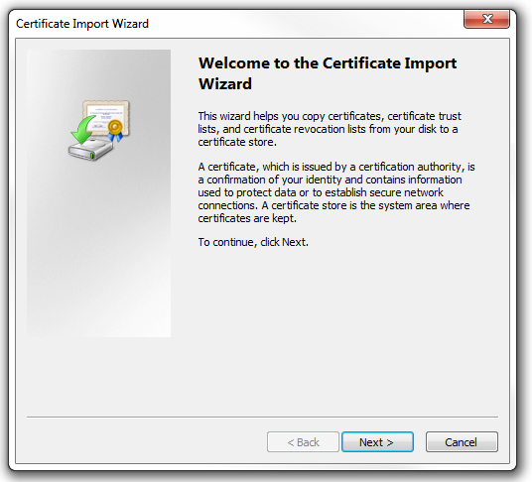

*Certificate Import Wizard*.

* + 1. Click: <*Next*>, <*Next*>, <*Finished*> to complete the installation of the certificate.  
         
        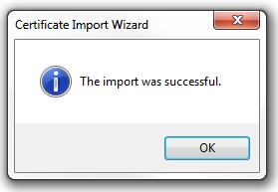

The certificate is successfully imported.

* 1. Start ArcMap.
  2. Select menu: *Customize* ► *Add-In Manager*.
  3. Check if GlobeSpotter for ArcGIS Desktop is now ‘Authenticated’. You can then proceed to paragraph .   
       
     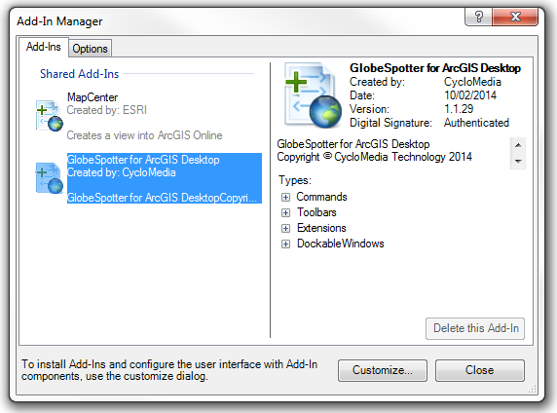

*Add-In Manager*, *Add-Ins* tab, check that GlobeSpotter for ArcGIS Desktop is now ‘*Authenticated*’.

1. If you start ArcMap for the first time after installing the Add-In, you will be shown the agreement form. Mark ‘*I have read and agree to the terms of use*’ as checked and click <*OK*>.  
     
   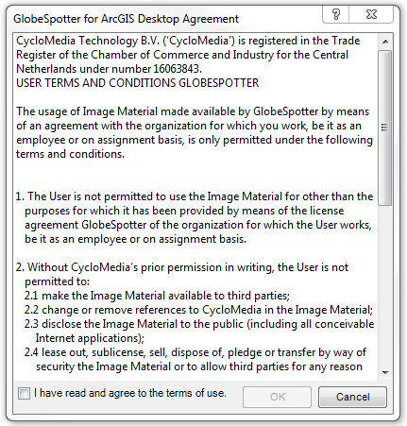

Agreement form.

1. If you do not get the agreement form, select menu: *Customize* ► *Extensions*.
2. Mark the extension *GlobeSpotter for ArcGIS Desktop* as checked. You will now get the agreement form (you will get this agreement form only once). Agree to the terms of use and click <*OK*>.  
     
   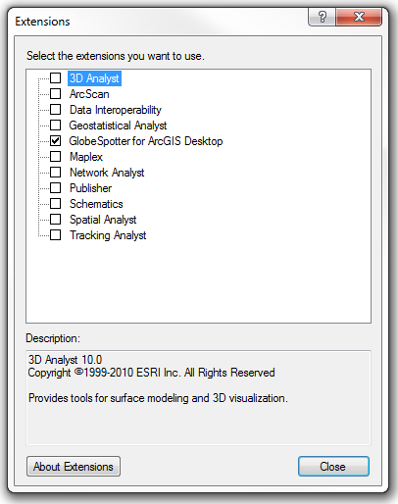

*Extensions* window, select the extension *GlobeSpotter for ArcGIS Desktop*.

1. Close the extensions window.
2. Open the GlobeSpotter toolbar: *Customize* ► *Toolbars* ► *GlobeSpotter*.
3. Select the *GlobeSpotter for ArcGIS Desktop* icon of the Cyclorama toolbar. You will now open the window *GlobeSpotter for ArcGIS Desktop*.   
     
     
     
   

GlobeSpotter toolbar.

The selected *GlobeSpotter for ArcGIS Desktop* icon.

1. Select the tab *Configuration*.
2. If you use a proxy server, you can enable *Use a proxy server* and enter the data about your proxy server.  
     
    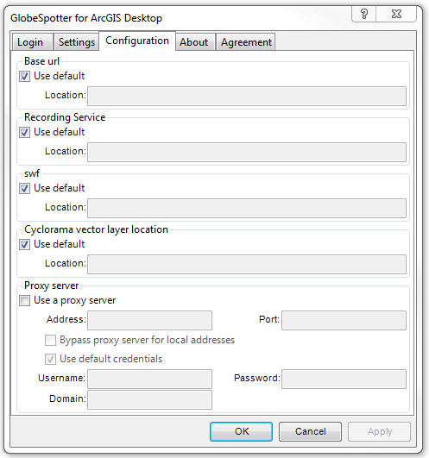

*GlobeSpotter for ArcGIS Desktop* Add-In window, *Configuration* tab.

1. If you are using a local installation, uncheck the base URL and the swf URL *Use default* option and enter the correct URLs at *Location* instead.
2. Select the *Login* tab.
3. Enter your username and password and press: <*Apply*>. If you see the message ‘*Login Successfully*’, you are ready to use GlobeSpotter for ArcGIS Desktop.   
     
   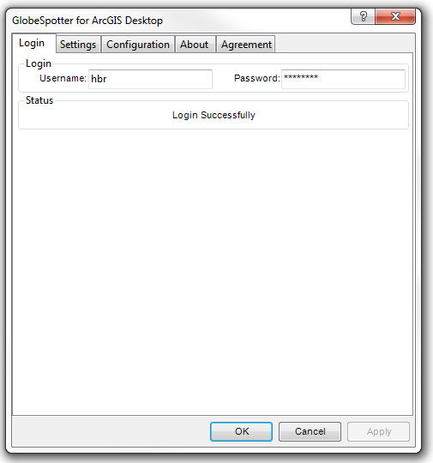

*GlobeSpotter for ArcGIS Desktop* Add-In window, *Login* tab.

# 2. How to use GlobeSpotter for ArcGIS Desktop

## 2.1 Exploring and viewing Cycloramas in ArcMap

### *2.1.1 How to show recent recording locations of Cycloramas*

1. Select *Add Recent Cyclorama Layer* in the GlobeSpotter toolbar.   
     
   

The selected *Add Recent Cyclorama Layer* icon.

1. In the *Table Of Contents* of ArcMap a new layer will appear as shown in the figure below. Zoom in on the map to a zoom level of at least 1:2000 to see the recording locations on the map (provided there are recordings in the area).  
     
    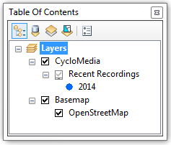

The layer with recent recordings in the *Table Of Contents*.

### *2.1.2 How to show historical recording locations of Cycloramas*

1. Select *Add Historical Cyclorama Layer* in the GlobeSpotter toolbar.   
     
   

The selected *Historical Cyclorama Layer* icon.

1. In the *Table Of Contents* a layer will appear showing historical recording locations. Zoom in on the map to a zoom level of at least 1:2000 to see these recording locations on the map (provided there are recordings in the area).  
     
   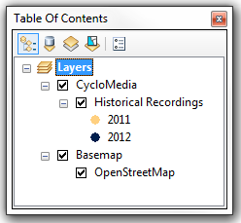

The layer with historical recording locations in the *Table Of Contents*.

1. The date range of recordings showed in the map can be modified via the window *CycloMedia Recording History*, which can be opened from the GlobeSpotter toolbar.  
     
   

The selected *CycloMedia Recording History* icon.

1. Move the sliders such that they include the date range of interest.   
     
   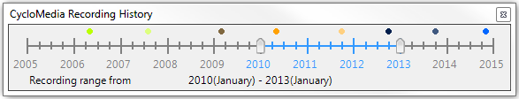

*CycloMedia Recording History* window.

### *2.1.3 How to configure the Cyclorama viewers*

1. Select the *Settings* tab of the *GlobeSpotter for ArcGIS Desktop* window.   
     
   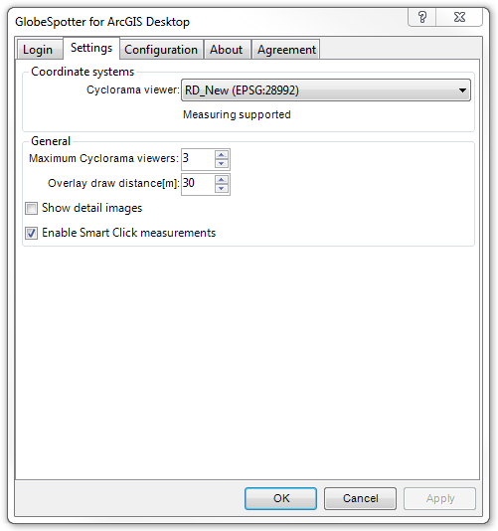

Cyclorama viewing settings in the *GlobeSpotter for ArcGIS Desktop* window.

1. Select the coordinate system which the viewer(s) should use.
2. Select the maximum number of Cyclorama viewers to be opened at the same time (three by default).
3. In some areas detailed images (acquired with additional cameras) are available, which can be made visible by enabling the option *Show detail images*.
4. Press <*Apply*> for the changes to take effect.

### *2.1.3 How to open Cycloramas*

1. Select the *Open Location Tool* in the GlobeSpotter toolbar.   
     
   

The selected *Open Location Tool* icon.

1. Click on a dot for the corresponding Cyclorama to open in a Cyclorama viewer. Click on another dot and a second Cyclorama will open.   
     
   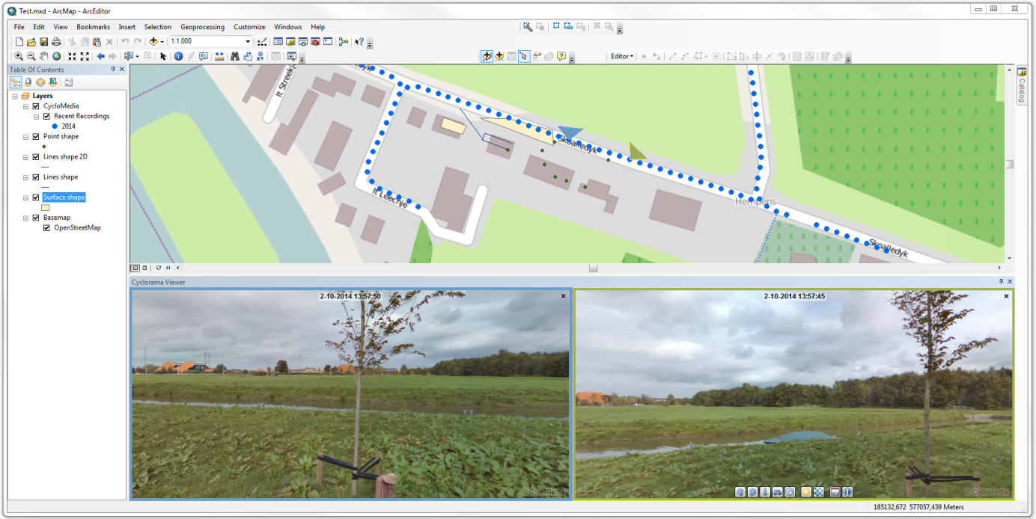

GlobeSpotter for ArcGIS Desktop with two Cyclorama viewers opened.

1. Optionally, right-click on the layer with recent or historical recording locations to open the feature layer context menu. With the option *Show in Cyclorama*, recording location markers in the Cycloramas can be turned on or off.   
     
   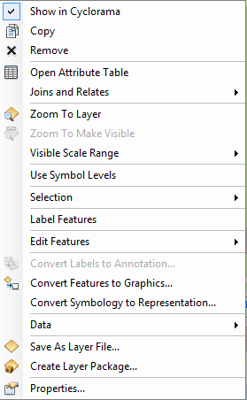

Feature layer context menu.

## 2.2 How to show vector data in Cycloramas

1. Add one of the various types of vector data to the Table Of Contents, such as:
   * Shapefiles
   * ArcSDE
   * Personal MDB
   * File GDB
2. Open a Cyclorama. Note that the vector data will now be shown in the Cycloramas. With the option *Show in Cyclorama* from the feature layer context menu, the vector layer in the Cycloramas can be turned on and off.  
     
   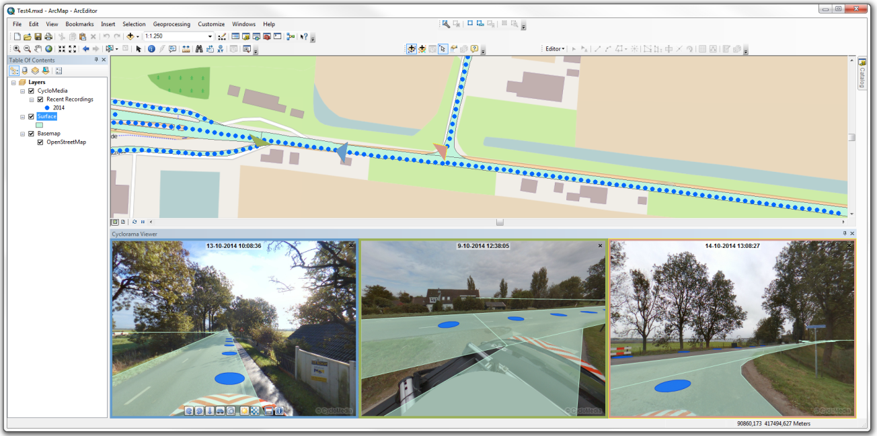

Showing vector data as overlay in the Cyclorama viewers.

1. Optionally, set the distance at which vector layer data is displayed in the *Settings* tab of the *GlobeSpotter for ArcGIS Desktop* window with the option *Overlay draw distance[m]*. The default distance is 30 meters, which means only vector data located within 30 meters of the recording location will be displayed.

## 2.3 Performing measurements

Measurements are stored in vector data layers. Point, line or surface measurements each are stored in separate point, line or polygon vector data layers. The following sections explain in detail how to perform the various types of measurements. To illustrate the principle of measuring, this manual will guide you through the process of performing standard measurements first, before explaining measuring with Smart Click (which is turned on by default).

### *2.3.1 Standard measurement – point measurement*

1. Add a point vector data layer to the map to store the measurement(s).
2. Open two or more Cycloramas in which the object to measure is clearly visible.
3. For standard measurements, disable Smart Click measurements in the *Settings* tab of the *GlobeSpotter for ArcGIS Desktop* window.  
     
    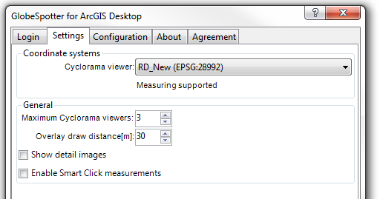

If necessary, disable Smart Click for performing standard measurements.

1. Right-click on the point vector layer and select: *Edit Features* ► *Start Editing* to start editing mode in ArcMap.  
     
   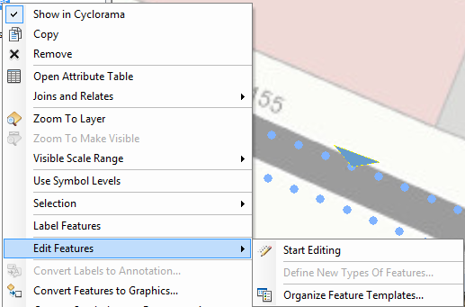

Start editing mode in the newly added vector layer.

1. Select the point layer in the *Create Features* window to start a point measurement.  
     
   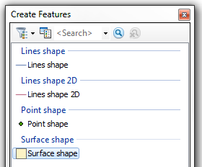

The *Create Features* window with several vector layers.

1. Select the point you want to measure in the first Cyclorama.
2. Select the same point in the other Cyclorama(s). The *Selected Measurement Details* window now shows information about the measurement.  
     
   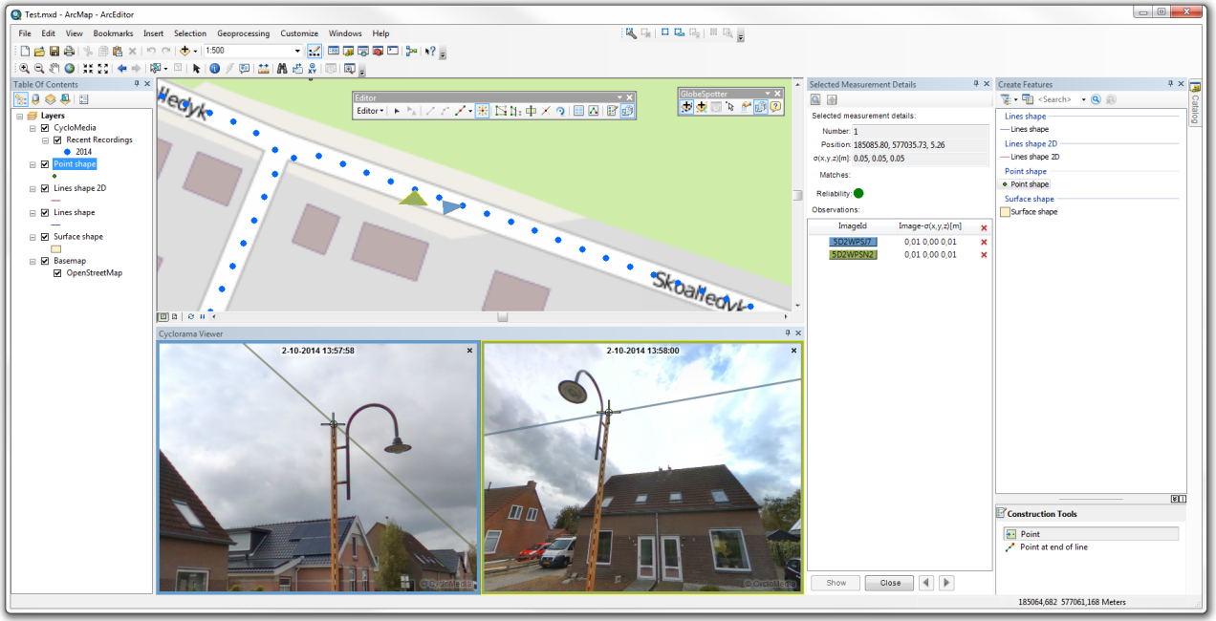

Performing a point measurement (without Smart Click).

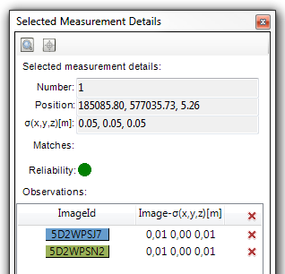

The *Selected Measurement Details* window.

1. Optionally, you can make the *Selected Measurement Details* window visible or invisible via the associated button in the GlobeSpotter toolbar.   
     
   

The *Selected Measurement Details* icon.

1. It is possible to remove observation points or to add more observation points. If you want to add observation points, open a new image and select the point you want to measure.
2. If you are finished with the measurement, click the <*Close*> button in the bottom of the *Selected Measurement Details* window.
3. If you are finished with your measurements, save the edits to the vector layer in the *Editor* toolbar in ArcMap, as shown in the figure below.   
     
   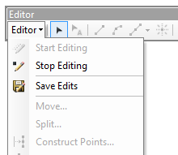

*Editor* toolbar in ArcMap to save edits and to start and stop editing.

### *2.3.2 Standard measurement – line / surface measurement*

1. Add a line or a polygon vector data layer to the map to store the measurement(s).
2. Open two or more Cycloramas in which the object to measure is clearly visible.
3. For standard measurements, disable Smart Click measurements in the *Settings* tab of the *GlobeSpotter for ArcGIS Desktop* window.
4. Right-click on the vector layer and select: *Edit Features* ► *Start Editing* to start editing mode in ArcMap.
5. Select the line or polygon layer in the *Create Features* window to start a line or a surface measurement.
6. Select the first point you want to measure in the first Cyclorama.
7. Then select the second and subsequent points you want to measure, until you have selected all the points you want to measure in the first Cyclorama.   
   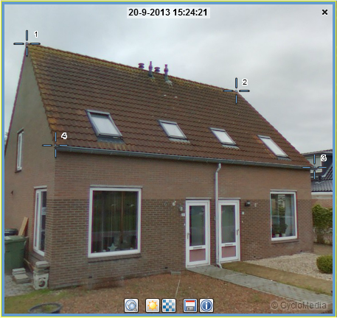

Select all the points in the first Cyclorama step by step.

1. Repeat the selection of points in the other Cyclorama(s) and make sure you select them in the same order as with the first Cyclorama.
2. The measurement is now complete. If you want to edit some measurement points, click the <*Edit*> button in the bottom of the *Selected Measurement Details* window. You can add or remove observation points for a selected measurement. Move through the measurement points with the ‘<’ and the ‘>’ buttons.
3. If you are finished with the measurement, click the <*Close*> button in the bottom of the *Selected Measurement Details* window.
4. Click on the *Finish Sketch* button on the *Feature Construction* toolbar to close the measurement.  
     
   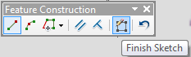

Use *Finish Sketch* on the *Feature Construction* toolbar to close the measurement.

1. If you are finished with your measurements, save the edits to the vector layer in the *Editor* toolbar in ArcMap.  
     
   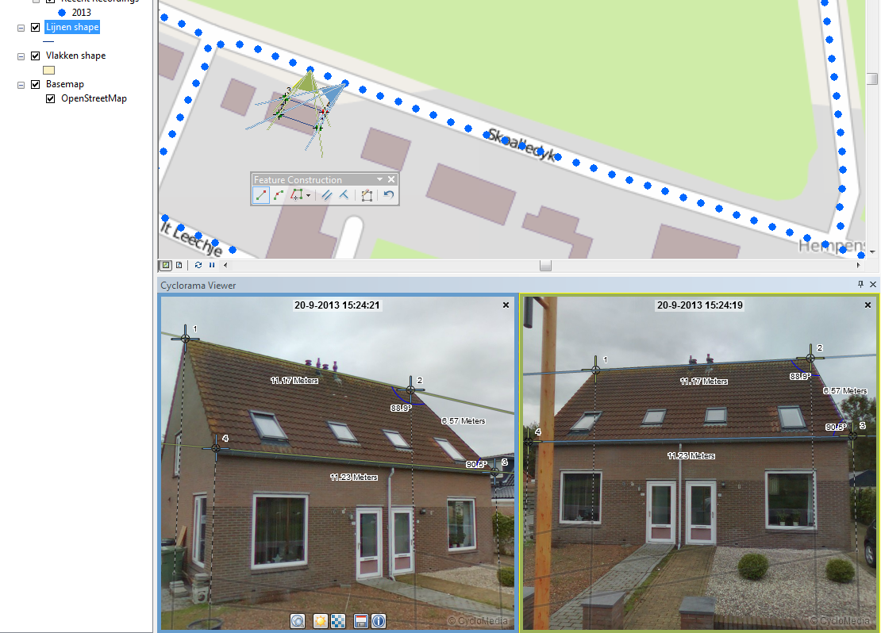

After selecting the points in the second Cyclorama, the measurement is complete.

### *2.3.3 Smart Click measurement – point measurement*

1. Add a point vector data layer to the map to store the measurement(s).
2. Open a Cyclorama in which the object to be measured is clearly visible.
3. Enable Smart Click measurements in the *Settings* tab of the *GlobeSpotter for ArcGIS Desktop* window.  
     
   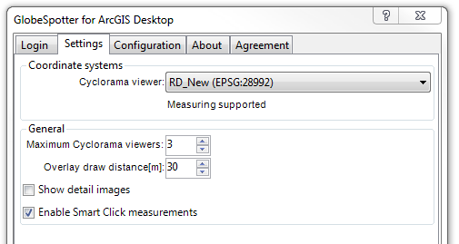

Enable Smart Click measurements.

1. Right-click on the vector layer and select: *Edit Features* ► *Start Editing* to start editing mode in ArcMap.
2. Select the point vector layer in the *Create Features* window to start a point measurement.
3. Select the point you want to measure in the Cyclorama.

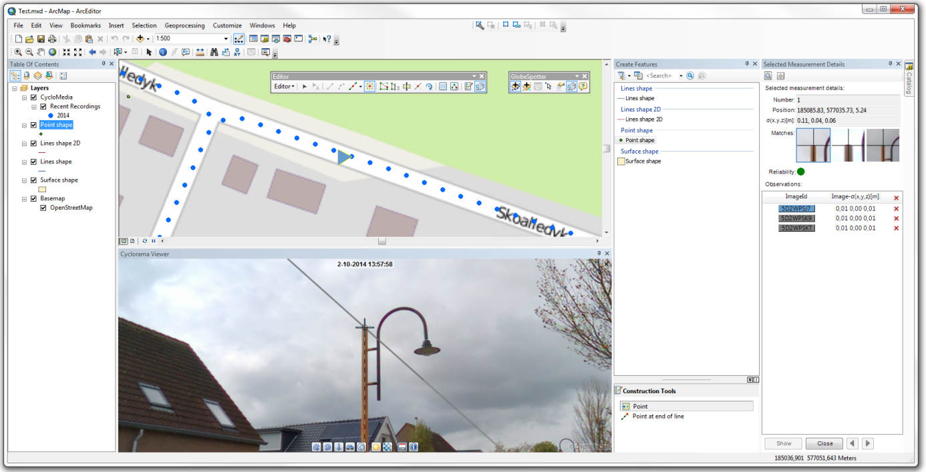

Point measurement (with Smart Click).

1. The *Selected Measurement Details* window will now show information about the measurement.  
     
   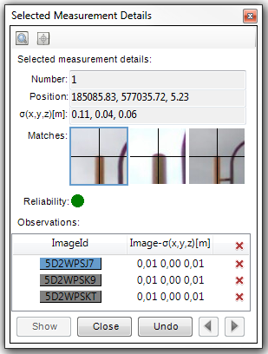

*Selected Measurement Details* window (with Smart Click).

1. You can check the other Cycloramas in which Smart Click found the object by selecting the image and by clicking on <*Show*>. It is possible to change the matching points found by Smart Click. You can also add or remove observation points. If you want to add more observation points, open a new Cyclorama and select the point you want to measure.  
     
   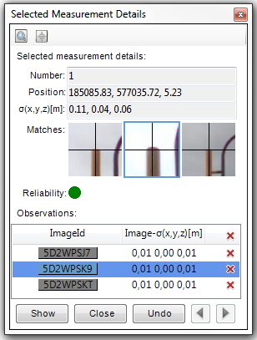

Check the results found by Smart Click.

1. If you are finished with the measurement, click the <*Close*> button in the bottom of the *Selected Measurement Details* window.
2. If you are finished with your measurements, save the edits to the vector layer in the *Editor* toolbar in ArcMap.

### *2.3.4 Smart Click measurement – line / surface measurement*

1. Add a line or a polygon vector data layer to the map to store the measurement(s).
2. Open a Cyclorama in which the object to be measured is clearly visible.
3. Enable Smart Click measurements in the *Settings* tab of the *GlobeSpotter for ArcGIS Desktop* window.
4. Right-click on the vector layer and select: *Edit Features* ► *Start Editing* to start editing mode in ArcMap.
5. Select the line or polygon layer in the *Create Features* window to start a line or a surface measurement.
6. Select the first point you want to measure in the Cyclorama.

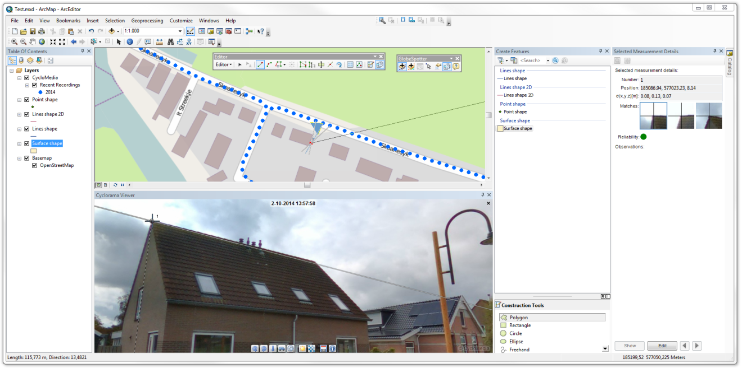

Line or polygon measurement after adding the first point.

1. The *Selected Measurement Details* window will now show information about the measurement.
2. If you want to edit or check some observation points, first click the <*Edit*> button.
3. You can check the other Cycloramas in which Smart Click found the object by selecting the image and by clicking on <*Show*>. It is possible to change the matching points found by Smart Click. You can also add or remove observation points. If you want to add more observation points, open a new Cyclorama and select the point you want to measure.
4. To add more measurement points, close the current point and add subsequent points by repeating steps 6, 7, 8 and 9. It is recommended to check all Smart Click measurement points.
5. Click on the *Finish Sketch* button on the *Feature Construction* toolbar to close the measurement.
6. If you are finished with your measurements, save the edits to the vector layer in the *Editor* toolbar in ArcMap.

### *2.3.5 How to import a measurement in a Cyclorama*

1. Select the *Edit Tool* in the *Editor* toolbar.  
     
   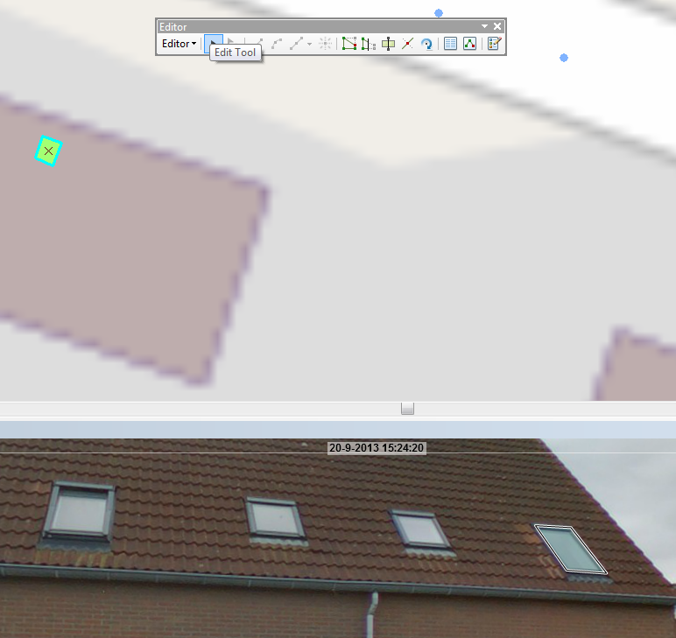

*Edit Tool* in the *Editor* toolbar.

1. Select a feature on the map to place the measurement back in the Cyclorama.  
     
   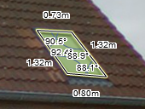

Measurement shown in Cyclorama.

1. Right-click on a (selected) feature and select *Edit Vertices* in the context menu to edit the measurement in the Cyclorama.  
     
   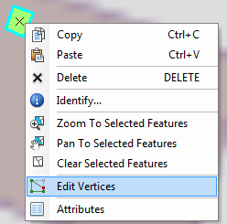

Select *Edit Vertices* to edit a measurement in a Cyclorama.

1. It is now possible to edit the measurement in the Cyclorama or on the map.
2. If you want to edit a measurement point in the Cyclorama, select that point in the map.
3. Use the *Sketch Properties* button in the *Editor* toolbar to view the values of the measurement points.   
     
   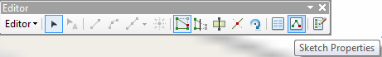

*Sketch Properties* in the *Editor* toolbar.

1. You can change the measurement values by selecting a point. The M value is the reference to the number of that point in the cyclorama .

*Edit Sketch Properties*.

### *2.3.6 Undo a measurement*

You can undo a measurement by click on the undo button

UndoButton.PNG

*Undo button measurements*

## Cyclorama search functionality

1. To start the cyclorama search functionality, click on the cyclorama search button in the GlobeSpotter toolbar.

ToolbarImageSearch.PNG

*Cyclorama search button*

1. You will now see the cyclorama search window.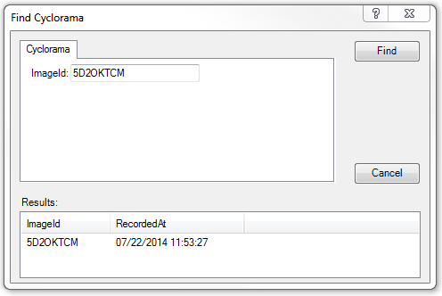

*Find Cyclorama window*

1. Enter a imageId and press the ‘Find’ button.
2. After a few seconds you will get the results
3. Double-click a result and you go to the cyclorama.